**Greg Seda**

**CS443 – Assignment 1**

**Question #1**

1. ReceiptNumber -> SalesDate

ProductID, ReceiptNumber -> Quantity Sold

ProductID -> ProductDescription

ItemNum -> ItemDescription

ProductID, ItemNum -> QuantityUsed

T1: Receipt(ReceiptNumber, SalesDate)

T2: Product(ProductID, ProductDescription)

T3: Item(ItemNum, ItemDescription)

T4: Sold((ProductID, ReceiptNumber)*, QuantitySold)

T5: Used((ProductID, ItemNum)*, QuantityUsed)

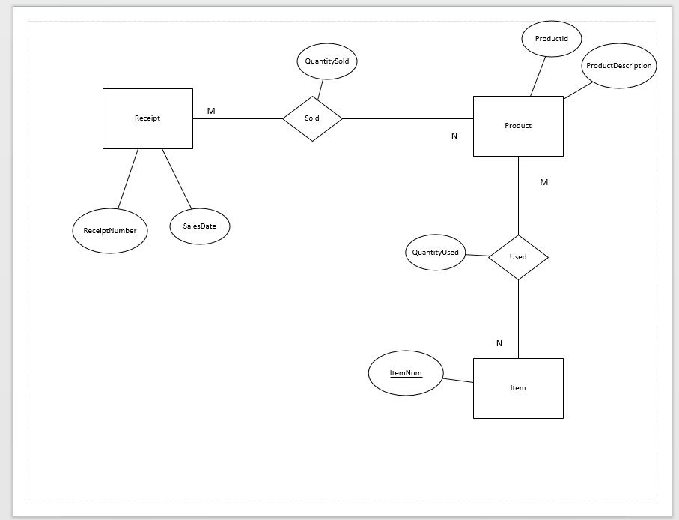

1. Code is on the txt file attached….

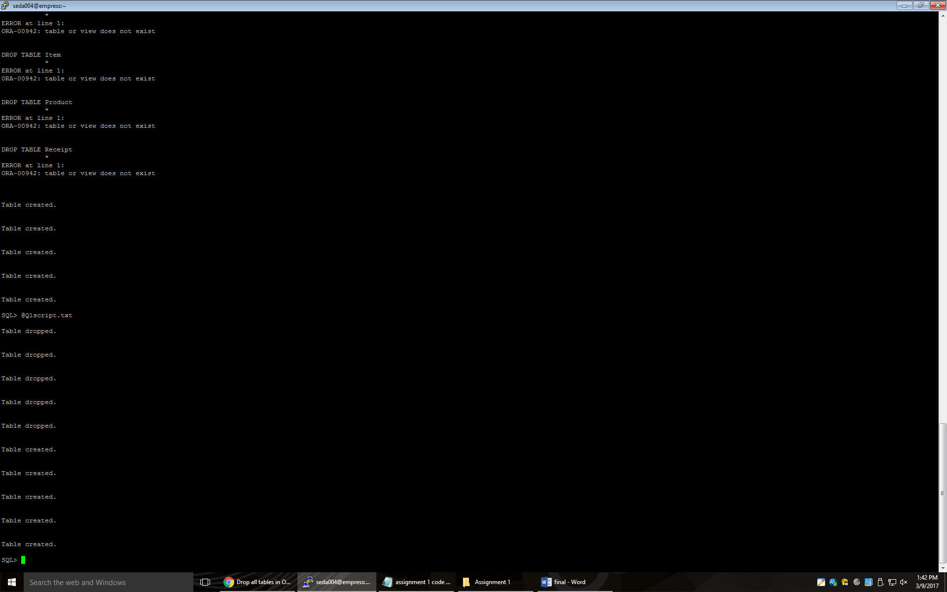

**Question #2**

Table 1: Patient (PatientID, PhysID, AmountOwing, RoomPhone, RoomNo, RoomRate, HospitalStayDays, PatientName, PatientAddress, AdminDate)

Table 2: Physician(PhysID, PhyName, PhysDept, DeptSupervisorId, TreatCost, TreatDesc, TreatId)

Table 1: Room(RoomNo, RoomRate, RoomPhone)

Table 2: Department(DeptId, DeptSupervisorId)

Table 3: Treatment(TreatId, TreatDesc, TreatCost)

Table 4: Physician(PhysID, PhysName, (TreatId, DeptId)*)

Table 5: Patient(PatientID, (PhysId, RoomNo)*, HospitalStaydays, PatientName, PatientAddress, AdminDate)

This is in 3rd normal form because they do not contain transitive or derived attributes. The AmountOwing attribute was removed because it can be derived from TreatCost, HospitalStayDays and RoomRate.

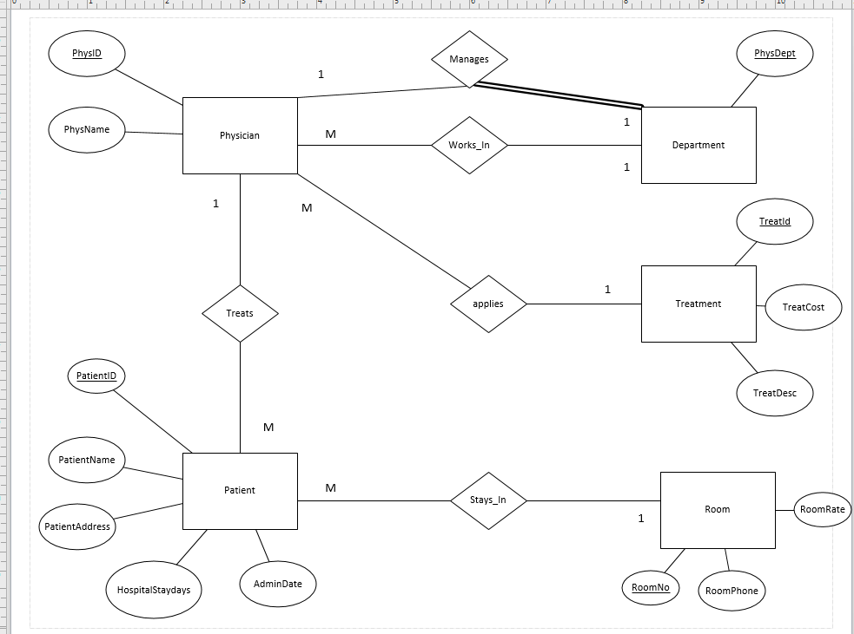

1. Code is on the txt file attached…..

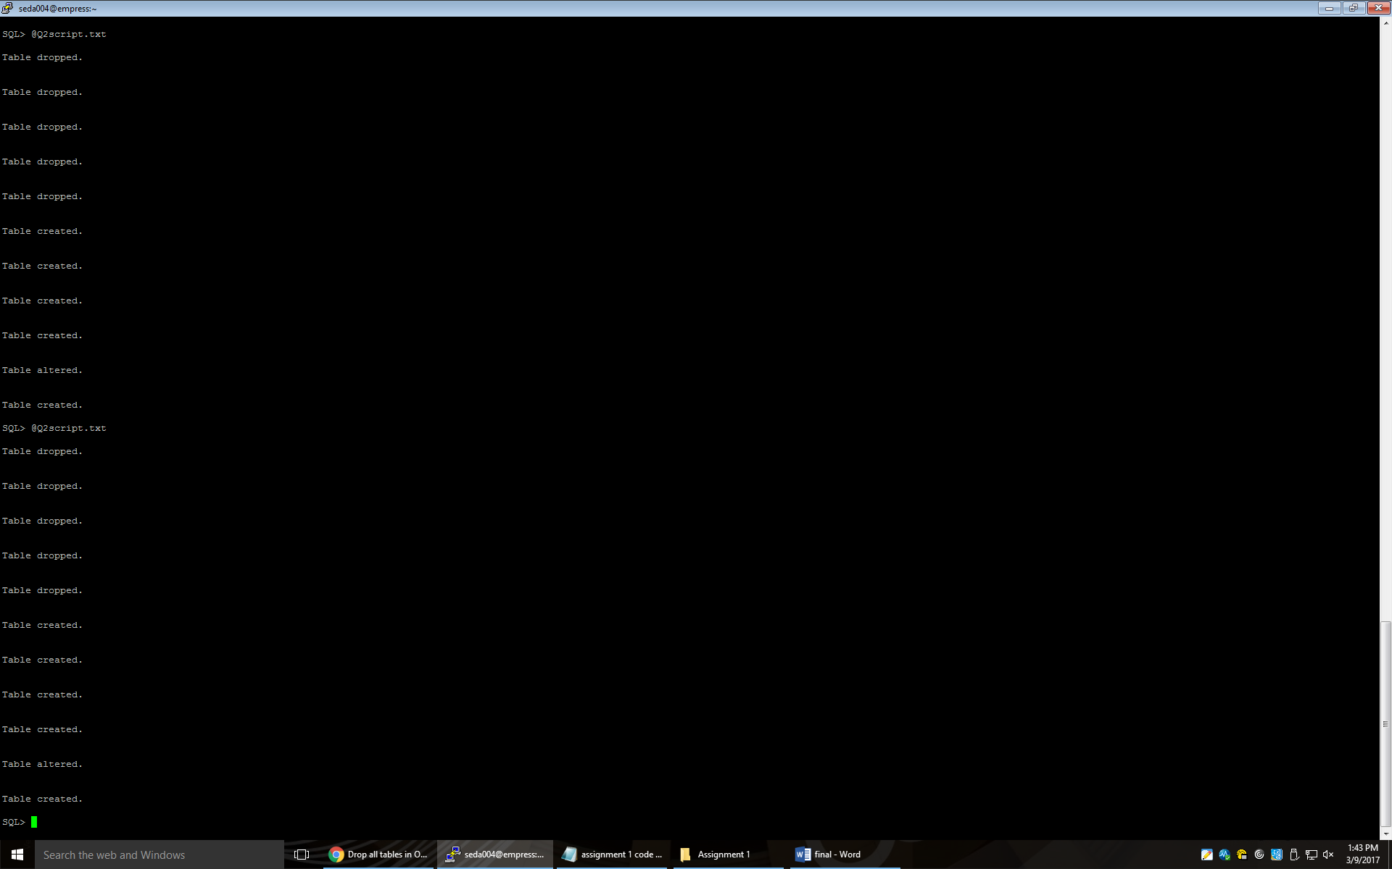

**Question #3**

Table 1: A(A1, A2)

Table 2: B(B1, B2, (A1, C1)*)

Table 3: C(C1, C2)

Table 4: D(D1, D5, D2, D3, D4)

Table 5: R3(C1,D1, D5, AttofR3)

Table 6: E(E1, (D1, D5)*, E2, AttOfR4)

Table 7: F(F1, F2, (E1, D1, D5)*, F3, F4, AttOfR5)

**Question #4**

Table 1: Bank(Code, Name, Addr)

Table 2: Bank-Branch(BranchNo, Code, Addr)

Table 3: Loan(LoanNo, Amount, Type, (BranchNo, Code)*)

Table 4: Account(AcctNo, Balance, type, (BranchNo, Code)*)

Table 5: Customer(SSN, Phone, Name, Addr)

Table 6: A-C(AcctNo, SSN)

Table 7: l-C(LoanNo, SSN)

**Question #5**

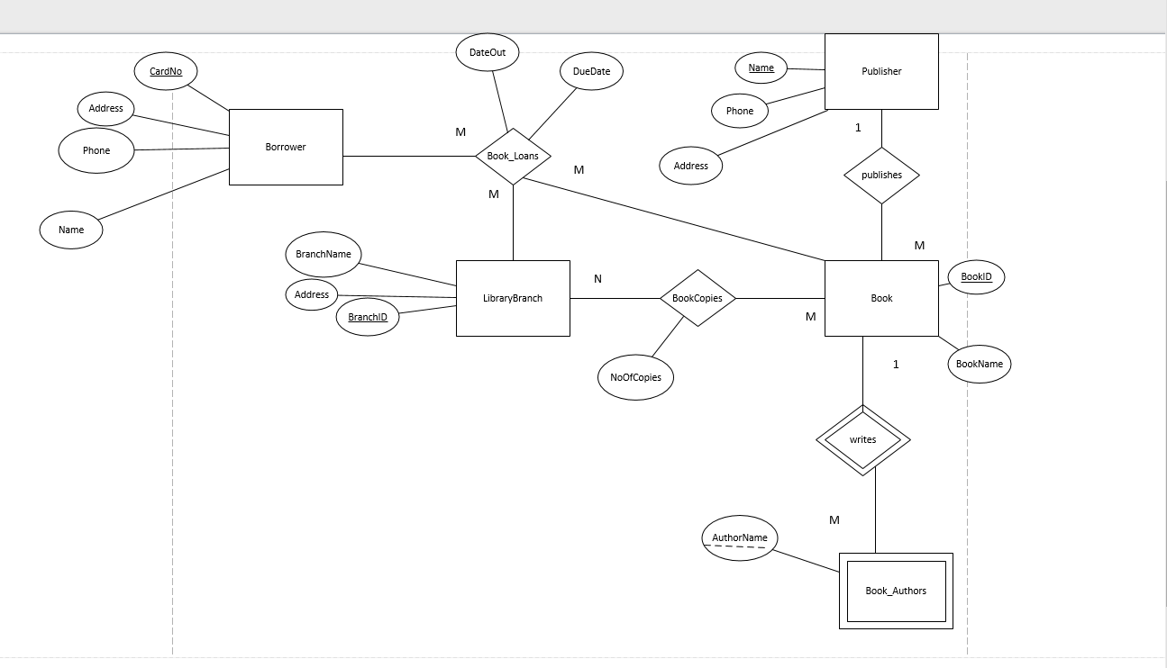

**Question #6**